PAVAI ARTS AND SCIENCE COLLEGE FOR WOMEN, ANAIPALAYAM
DEPARTMENT OF COMMERCE

GUEST LECTURE
ON
BUDDING ENTREPRENEURS
NEWS
A Guest Lecture on the topic, ‘Budding Entrepreneurs’ was organised by the department of Commerce of Pavai Arts and Science College for Women on 03.10.2023 in Keerthi Hall at 2.30 pm. All UG and PG students of the Department of commerce attended the Guest Lecture.
The programme started with the prayer song by the students. Ms. P. Shalini III B.Com welcomed the gathering. Ms. K.S. Janani of III B.Com introduced the Guest Speaker Mr. Dr. A. Apthul Kadhar, M.B.A., M.Phil., Ph.D., Field Coordinator PU-IEDP-Hub, Periyar University, Salem. The Guest speaker in his special address explained about Budding Entrepreneurs. Many young entrepreneurs fail in the first term of their business because they fail to handle perilous obstacle. He also familiarised some renowned entrepreneurs who succeeded by their proficiency in solving problem, making decision, and hard work. These skills of the entrepreneurs are not just good for business but also for life. He presented the lecture through PowerPoint presentation. Students acquired knowledge about the budding entrepreneurs.
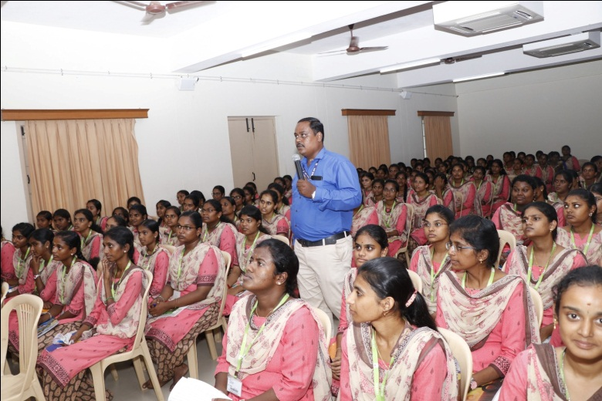
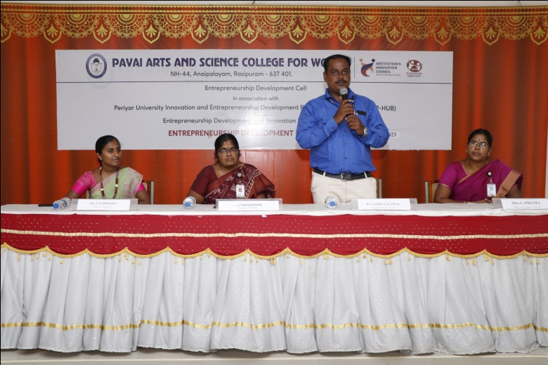
Ms. Sharupriya of III B. Com (CA) delivered the Vote of Thanks and the Guest Lecture came to an end with National Anthem.

